Actions
Situation
Understanding
What is happening now?

What keeps this issue going?

Who is affected and how?

What is triggering what is happening now?

What has happened in the past?

Who is in the family? What services are currently involved?
William Mather Box (16) Claire Mather (mam) Carl Box (dad) Lucy Mather Box (sister).
Charlotte Blenkion – social worker CP plan since November 2023
What could happen if things don’t change?
What positives and strengths are there? THINK FAMILY NETWORK.
What changes need to happen? (use this box to hypothesise using IF and THEN statements)
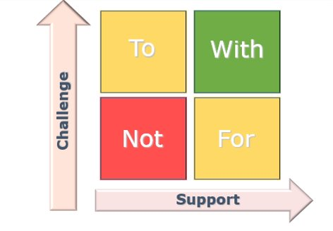
How will we do it? (use this box to set out the actions you will now take which respond to your hypothesis)

